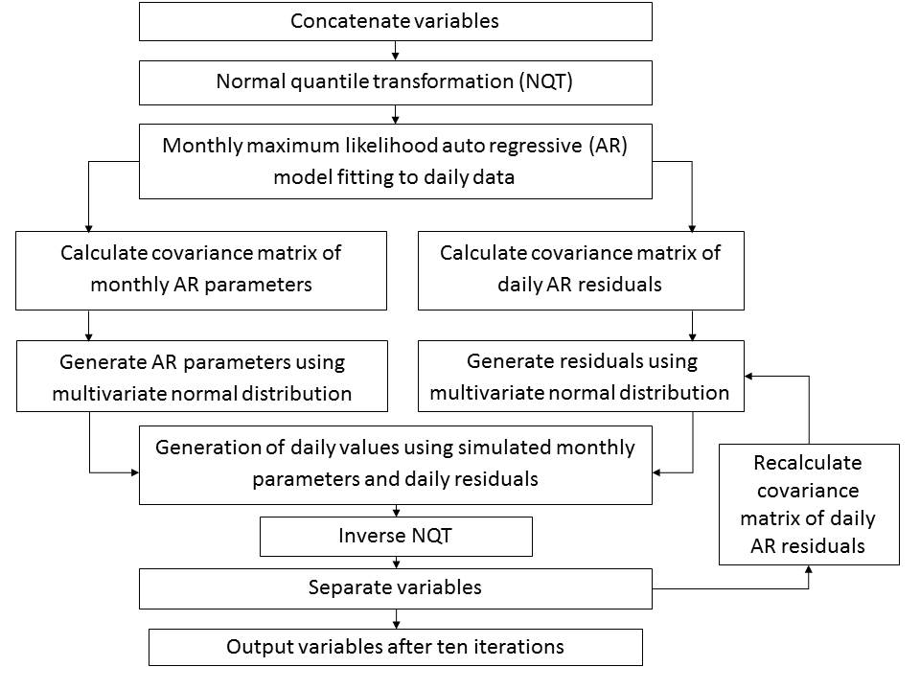

Figure XX: Schematic of simulation procedure.



Figure XX: Return value of heat waves for the whole domain and five countries within the domain for the IMAGE simulation of 10,000 years in 30-year slices (blue lines) and input CORDEX data for 1971-2000 (black line). Boxplots show the distribution of the IMAGE simulations at each return period.



Figure XX: Return values of heat waves for the whole domain and five countries within the domain for the IMAGE simulation of 10,000 years for CORDEX input data for 1971-2000 (black points), simulated 1971-2000 data (grey line), simulated RCP4.5 2021-2050 (yellow line), simulated RCP8.5 2021-2050 (orange line), simulated RCP4.5 2071-2100 (red line) and RCP 8.5 2071-2000 (brown line).

Figure XX: Return value of 3-month SPEI droughts for the whole domain and five countries within the domain for the IMAGE simulation of 10,000 years in 30-year slices (blue lines) and input CORDEX data for 1971-2000 (black line). Boxplots show the distribution of the IMAGE simulations at each return period.

Figure XX: Return values of 3-month SPEI droughts for the whole domain and five countries within the domain for the IMAGE simulation of 10,000 years for CORDEX input data for 1971-2000 (black points), simulated 1971-2000 data (grey line), simulated RCP4.5 2021-2050 (yellow line), simulated RCP8.5 2021-2050 (orange line), simulated RCP4.5 2071-2100 (red line) and RCP 8.5 2071-2000 (brown line).

Figure XX: Varying maps of heat waves across Europe for heat waves in France, as measured by intensity, with return periods of 100 years.